System and Software Architecture Description (SSAD)

Pediatric Trauma Society Research Investigator Databank (PTS-RID)

#1

Kenda Albertson: IIV&V, Shaper
Georges Hatem: Project Manager, Lifecycle Planner
Mehrdad Mahdavi: Project Manager, Feasibility Engineer
Nicholas McCall: Operational Concept Engineer, Requirement Engineer
Junjian Wang: System Architect, Prototyper

March 31th 2013

Version History
Date | Author | Version | Changes made | Rationale
10/15/12 | SA & JW | 1.0 | - First System and Software Architecture Description | - Based on the negotiations with the client so far
10/20/12 | SA & JW | 1.1 | - Finish section 2.1.4 and 2.2 to complete the section 1 & 2 | - Based on the negotiations with the client and info from winbook so far
10/21/12 | SA & JW | 1.2 | - Fix some problems in the system behavior section | - Based on the evaluation from IIV&Ver
10/29/12 | SA & JW | 1.3 | - Fix some problems in the section 1 & 2 | - Based on the evaluation and comments from IIV & Ver and TA
11/04/12 | SA & JW | 1.4 | - Fix some problems in the section 1& 2 (cont’d) | - Based on the evaluation from Professors
11/14/12 | SA & JW | 1.5 | - Fix some problems in the system behavior part | - Based on the evaluation from TA and IIV & Ver.
11/26/12 | SA & JW | 1.6 | - Complete all sections | - Based on the negotiation with the client
12/04/12 | SA & JW | 2.0 | - Fix some problems in section 4 | - Based on the evaluation of the whole team
12/10/12 | SA & JW | 2.1 | - Fix some problems throughout the whole document | - Based on the evaluation of IIV & Ver and Professors
2/10/13 | JW | 3.0 | - Fix some problems throughout the document | - Based on the evaluation of TA
2/19/13 | JW | 3.1 | - Fix some problems throughout the document | - Based on the evaluation of TA
3/30/13 | JW | 4.0 | - Fix some problems throughout the document | - Based on the evaluation of TA and feedback during the development

Table of Contents
System and Software Architecture Description (SSAD) i
Version History ii
Table of Contents iii
Table of Tables iv
Table of Figures v
1. Introduction 1
1.1 Purpose of the SSAD 1
1.2 Status of the SSAD 1
2. System Analysis 2
2.1 System Analysis Overview 2
2.2 System Analysis Rationale 19
3. Technology-Independent Model 20
4. Technology-Specific System Design 21
4.1 Design Overview 21
4.2 Design Rationale 35
5. Architectural Styles, Patterns and Frameworks 36

Table of Tables
Table 1: Actors Summary 3
Table 2: Artifacts and Information Summary 5
Table 33 Comparison table 35

Table of Figures
Figure 1: System Context Diagram 2
Figure 2: Artifacts and Information Diagram 4
Figure 3: Process Diagram 6
Figure 4: Hardware Component Class Diagram 21
Figure 5: Software Component Class Diagram 22
Figure 6: Deployment Diagram 23
Figure 7: Supporting Software Component Class Diagram 24
Figure 8: Boundary & Control Class Diagram 27

Introduction

Purpose of the SSAD

The SSAD is the core document that is the result of design and analysis of the system and its requirements which is used by almost all the stakeholders, including the programmer, maintainer and clients. SSAD shows the whole structure of the system, the components used in the system and the interoperation between them. The developers use the SSAD as a reference to implement the system.

Status of the SSAD

This SSAD is of the version 4.0 which mainly fix some problems throughout the whole document based on the comments from TA and the feedback during the development. The document is for IOC1 Package.

System Analysis

System Analysis Overview
The Pediatric Trauma Society is a newly formed national organization dedicated to improving the outcomes of injured children. PTS aims to be a global leader in the field of pediatric trauma and injury prevention through optimal care guidelines, education, research, and advocacy. The PTS-RID system will pull key data from the external database PubMed and store all of them in a local database in order to enable Members to search it for forming collaborations. The database will act to facilitate research on a national basis and will be instrumental in improving pediatric trauma outcomes.

System Context

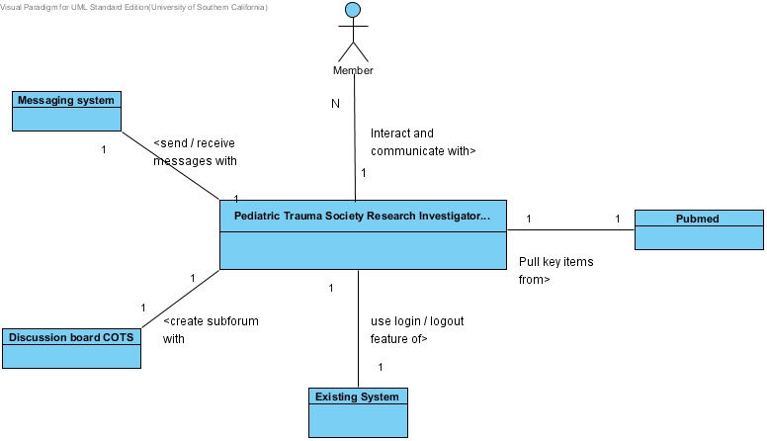
Figure 1: System Context Diagram

Table 1: Actors Summary
Actor | Description | Responsibilities
Pubmed | A free database providing academic topics and references in the domain of biomedicine and science. | - Expose API for accessing database items in the area of pediatrics, including journals, abstracts, MESH terms and so on.
Discussion board COTS | The COTS specializing at providing discussion-board-related functionality. | - Provision functionality of subforum creation, posts and comments
Members | The users which are the members of PTS | - Do searching  - Create Topic (Group) for discussion  - Send/Receive Messages  - View message history  - Post and comment  - Upload CV/Resume  - View graph in collaboration  - View articles
Existing System | A developed system of PTS | - Integrate and interact with PTS-RID, and provide login / logout feature to PTS-RID
Messaging System | A system that provides messaging functionality | - Provision sending/receiving message and viewing message history functionality

Artifacts & Information
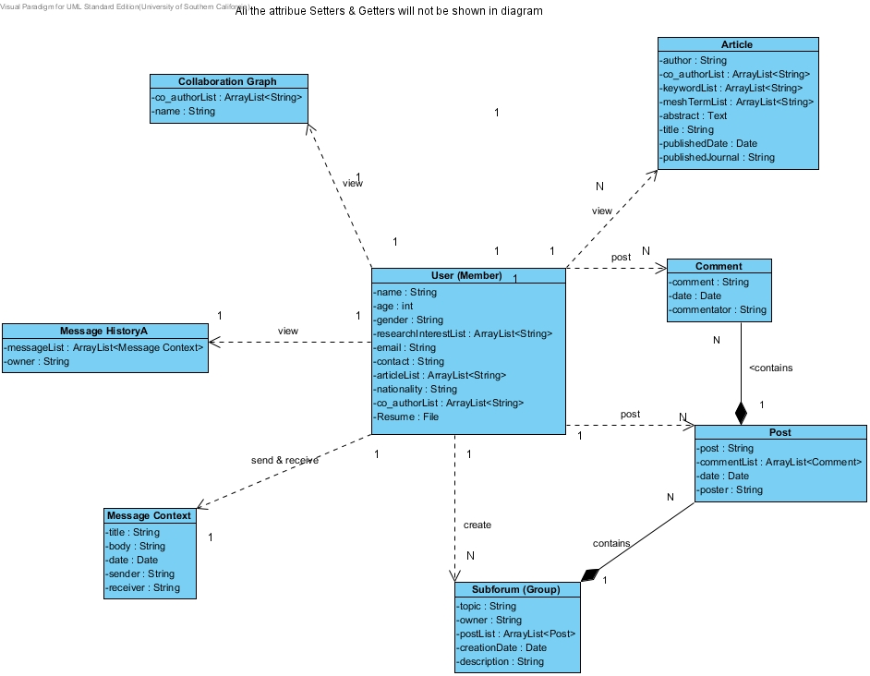
Figure 2: Artifacts and Information Diagram

Table 2: Artifacts and Information Summary
Artifact | Purpose
User (Member) | Contains all information about the user that include personal information (name, gender, research area, etc.), the list of articles that he/she has ever published on Pubmed and the list of authors that he/she has ever collaborated with
Collaboration Graph | Illustrates the collaboration networks where the user has cooperate with other members in certain research area
Subforum (Group) | Contains all the public posts and comments by which members communicate with one another upon their research
Post | Post posted by a certain user
Comment | Comment made on a certain post
Message Context | Contains the message information and the context including sending / receiving date, sender and receiver
Message History | Contains the history of all the private messages that the user sends to/receives from other members
Article | Article that has been published in Pubmed by certain authors

Behavior
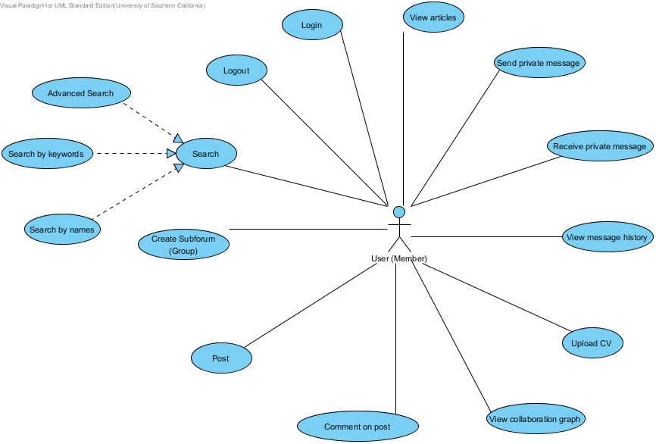
Figure 3: Process Diagram

Capability

Process Search
Table 8: Process Description
Identifier | UC-3: Search
Purpose | Allow users to search the information they want by keyword, MESH terms and names.
Requirements | WC_1527, WC_1500, WC_1493, WC_1492, WC_1491
Development Risks | Inability to handle 100 members doing concurrent search jobs.  Response time not guaranteed.
Pre-conditions | The user has logged in, and is currently on the profile page
Post-conditions | A list of search result will show on the screen, or a message that nothing has been found

Table 9: Typical Course of Action
Seq# | Actor’s Action | System’s Response
1 | Input search item, and click Search Button
2 |  | Sends the request to PTS-RID back-end to do search processing, and find corresponding items
3 |  | Display the list of search results
Table 10: Exceptional Course of Action
Seq# | Actor’s Action | System’s Response
1 | Refer to typical course of action
2 |  | Sends the request to PTS-RID back-end to do search processing, and fail to find corresponding items
3 |  | Display the message that no item matches your search criteria

Process Create Subforum (Group)
Table 11: Process Description
Identifier | UC-4: Create Subforum (Group)
Purpose | Create a subforum (group) for member discussion
Requirements | WC_1495
Development Risks | None
Pre-conditions | The user has logged in, and is currently on the profile page
Post-conditions | The group will successfully be created, or fail to be created

Table 12: Typical Course of Action
Seq# | Actor’s Action | System’s Response
1 | Configure group parameters, and click Create button
2 |  | Sends the request to PTS-RID back-end to do group creating processing, and group successfully created
3 |  | Show the message that the group has been successfully created, and redirect the user to the group page
Table 13: Exceptional Course of Action
Seq# | Actor’s Action | System’s Response
1 | Refer to typical course of action
2 |  | Sends the request to PTS-RID back-end to do group creating processing, and group cannot be created due to the name of the group not unique, or the information incorrectly being filled out
3 |  | Display the message that group creation fails

Process Post
Table 14: Process Description
Identifier | UC-5: Post
Purpose | Post a message on the discussion board
Requirements | WC_1494
Development Risks | None
Pre-conditions | The user has logged in and the user is on any group where the user can post messages
Post-conditions | The post message will successfully be created, or fail to be created

Table 15: Typical Course of Action
Seq# | Actor’s Action | System’s Response
1 | Compose the message the user wants to post, and click Go button
2 |  | Sends the request to PTS-RID back-end to do user-post processing, and the post successfully created
3 |  | Show that the message has been successfully posted
Table 16: Exceptional Course of Action
Seq# | Actor’s Action | System’s Response
1 | Refer to typical course of action
2 |  | Sends the request to PTS-RID back-end to do user-post processing, and the post cannot be created due to some reasons like the word count outnumbers the limitation.
3 |  | Show that the message has not been successfully posted.

Process Comment on post
Table 17: Process Description
Identifier | UC-6: Comment on post
Purpose | Comment on a post message on the discussion board
Requirements | WC_1494
Development Risks | None
Pre-conditions | The user has logged in, the user is currently on any group page where the user can post messages and there is any post message on which the user can comment
Post-conditions | The comment on post message will successfully be created, or fail to be created

Table 18: Typical Course of Action
Seq# | Actor’s Action | System’s Response
1 | Compose the comment the user wants to make on the post message, and click Go button
2 |  | Sends the request to PTS-RID back-end to do comment on user-post processing, and the comment is successfully created
3 |  | Show that the comment on the post message has been successfully posted
Table 19: Exceptional Course of Action
Seq# | Actor’s Action | System’s Response
1 | Refer to typical course of action
2 |  | Sends the request to PTS-RID back-end to do comment on user-post processing, and the comment cannot be created due to some reasons like the word count outnumbers the limitation.
 |  | Show that the comment on the post message has not been successfully posted

Process View Collaboration graph
Table 20: Process Description
Identifier | UC-7: View collaboration graph
Purpose | View the collaboration relationship that the user has ever established with other members in a visualization way
Requirements | WC_1494
Development Risks | None
Pre-conditions | The user has logged in and the user is currently on the user profile page
Post-conditions | The collaboration graph is displayed, or show the message that no relationship found

Table 21: Typical Course of Action
Seq# | Actor’s Action | System’s Response
1 | Click the View button
2 |  | Sends the request to PTS-RID back-end to do fetching collaboration relationship processing, and the relationship is successfully obtained
3 |  | Build the graph in the client side and show the collaboration graph on the screen
Table 22: Exceptional Course of Action
Seq# | Actor’s Action | System’s Response
1 | Refer to typical course of action
2 |  | Sends the request to PTS-RID back-end to do collaboration relationship processing, and find that the user has not established any relationship with others
3 |  | Show the message that the user does not have any relationship with any of the members

Process Upload CV
Table 23: Process Description
Identifier | UC-8: Upload CV
Purpose | Upload CV in order to be viewed by other members
Requirements | WC_1498
Development Risks | None
Pre-conditions | The user has logged in, and the user is currently on the user profile page
Post-conditions | The CV is successfully uploaded, or fail to be uploaded

Table 24: Typical Course of Action
Seq# | Actor’s Action | System’s Response
1 | Click the Browse button locate the CV on the local, and click Upload button to upload file
2 |  | Sends the request to PTS-RID back-end to do CV uploading processing, and CV is successfully uploaded.
3 |  | Show the uploaded CV

Process Send private message
Table 26: Process Description
Identifier | UC-9: Send private message
Purpose | Send private message to other members in order to facilitate collaboration
Requirements | WC_1496
Development Risks | None
Pre-conditions | The user has logged in and the user is currently on the user profile page
Post-conditions | The message has been successfully sent and shown on the message list, or fail to be sent

Table 27: Typical Course of Action
Seq# | Actor’s Action | System’s Response
1 | Compose the message, designate the receiver and click Send button
2 |  | Sends the request to PTS-RID back-end to do sending private message processing, and the message is successfully sent.
3 |  | Show the message being successfully sent and shown on the message list
Table 28: Exceptional Course of Action
Seq# | Actor’s Action | System’s Response
1 | Refer to typical course of action
2 |  | Sends the request to PTS-RID back-end to do sending private message processing, and the message cannot be sent due to some reasons like the word count outnumbers the limitation..
 |  | Show the message that the message has not been successfully sent

Process Receive private message
Table 29: Process Description
Identifier | UC-10: Receive private message
Purpose | Receive private message from other members in order to facilitate collaboration
Requirements | WC_1496
Development Risks | None
Pre-conditions | The user has logged in and the user is currently on the user profile page
Post-conditions | The received message is shown on the message list, or the message that no new message

Table 30: Typical Course of Action
Seq# | Actor’s Action | System’s Response
1 | Click the Message Notification link
2 |  | Sends the request to PTS-RID back-end to do receiving private message processing, and find newly-received message
3 |  | Show the received message

Table 31: Exceptional Course of Action
Seq# | Actor’s Action | System’s Response
1 | Refer to typical course of action
2 |  | Sends the request to PTS-RID back-end to do receiving private message processing, and fail to find any newly-received message
3 |  | Show the message of No New Message

Process View message history
Table 32: Process Description
Identifier | UC-11: View message history
Purpose | View the complete history of the message that the user has ever sent or received.
Requirements | WC_1497
Development Risks | None
Pre-conditions | The user has logged in and the user is currently on the user profile page
Post-conditions | The message history is shown on the screen, or the message that no message sent or received

Table 33: Typical Course of Action
Seq# | Actor’s Action | System’s Response
1 | Click the View button
2 |  | Sends the request to PTS-RID back-end to do message history processing, and find the message history
3 |  | Show the message history

Table 34: Exceptional Course of Action
Seq# | Actor’s Action | System’s Response
1 | Refer to typical course of action
2 |  | Sends the request to PTS-RID back-end to do message history processing, and fail to find the message history for having not sent or received any message
3 |  | Show No Messages in the history

Process View articles
Table 35: Process Description
Identifier | UC-12: View articles
Purpose | View the list articles that the user has ever published on Pubmed
Requirements | WC_1501
Development Risks | None
Pre-conditions | The user has logged in and the user is currently on the user profile page
Post-conditions | The list of articles is shown on the screen, or the message that no articles found

Table 36: Typical Course of Action
Seq# | Actor’s Action | System’s Response
1 | Click the View Articles button
2 |  | Sends the request to PTS-RID back-end to do article fetching processing, and the list of articles are successfully obtained
3 |  | Show the list of articles

Table 37: Exceptional Course of Action
Seq# | Actor’s Action | System’s Response
1 | Refer to typical course of action
2 |  | Sends the request to PTS-RID back-end to do article fetching processing, and the article cannot be found
 |  | Show that no article exists

Process Advanced Search
Table 38: Process Description
Identifier | UC-13: Advanced search
Purpose | Facilitate users to search the articles they want by MESH terms.
Requirements | WC_1527, WC_1491
Development Risks | Inability to handle 100 members doing concurrent search jobs.  Response time not guaranteed.
Pre-conditions | The user has logged in, and the user is currently on the user profile page
Post-conditions | A list of articles will show on the screen, or the message that no item is found

Table 39: Typical Course of Action
Seq# | Actor’s Action | System’s Response
1 | Select Country and State item, and click Search Button
2 |  | Sends the request to PTS-RID back-end to do advanced term search processing, and find the corresponding items
3 |  | Display the list of articles

Table 40: Exceptional Course of Action
Seq# | Actor’s Action | System’s Response
1 | Refer to typical course of action
2 |  | Sends the request to PTS-RID back-end to do advanced search processing, and fail to find any corresponding item
3 |  | Display the message that no item matches your search criteria

Process Search by keywords
Table 41: Process Description
Identifier | UC-14: Search by keywords
Purpose | Facilitate users to search the articles they want by keywords.
Requirements | WC_1527, WC_1493
Development Risks | Inability to handle 100 members doing concurrent search jobs.  Response time not guaranteed.
Pre-conditions | The user has logged in, and the user is currently on the user profile page
Post-conditions | A list of articles will show on the screen, or the message that no item is found

Table 42: Typical Course of Action
Seq# | Actor’s Action | System’s Response
1 | Input search keyword, and click Search Button
2 |  | Sends the request to PTS-RID back-end to do keyword search processing, and find the corresponding items
3 |  | Display the list of articles
Table 43: Exceptional Course of Action
Seq# | Actor’s Action | System’s Response
1 | Refer to typical course of action
2 |  | Sends the request to PTS-RID back-end to do keyword term search processing, and fail to find any corresponding item
3 |  | Display the message that no item matches your search criteria

Process Search by names
Table 44: Process Description
Identifier | UC-15: Search by names
Purpose | Facilitate users to search the profiles of other members they want by names.
Requirements | WC_1527, WC_1492
Development Risks | Inability to handle 100 members doing concurrent search jobs.  Response time not guaranteed.
Pre-conditions | The user has logged in, and the user is currently on the user profile page
Post-conditions | A list of user profiles will show on the screen, or the message that no item is found

Table 45: Typical Course of Action
Seq# | Actor’s Action | System’s Response
1 | Input search name, and click Search Button
2 |  | Sends the request to PTS-RID back-end to do name search processing, and find the corresponding items
3 |  | Display the list of user profiles
Table 46: Exceptional Course of Action
Seq# | Actor’s Action | System’s Response
1 | Refer to typical course of action
2 |  | Sends the request to PTS-RID back-end to do name search processing, and fail to find any corresponding item
3 |  | Display the message that no item matches your search criteria

Modes of Operation

The PTS-RID has only one mode, therefore there is nothing more to describe of the mode of operation.
Note that when the system does daily backup automatically, the server is still available to users.

System Analysis Rationale
Based on what we have analyzed from the system, we have figured out the following aspects that are less obvious or counter-intuitive:
- User: the users here stand for those who have already been a member of PTS the number of which is around 150. Note they do not need to sign up to access the PTS-RID pages because some of their profiles have been stored in the database once they joined in the society.
- Subforum: the concept represents the discussion board or the group where members can post and comment after it has been created.
- Pubmed: Pubmed is a free external database of government from where our system pulls items upon the domain of pediatrics.
- Login/Logout: Since our system will use the login/logout feature from existing PTS system, these two cases are removed from the document.

Technology-Independent Model
The section is skipped because all the key factors like particular hardware platforms, programming language, programming paradigm and so on have been specified.

Technology-Specific System Design

Design Overview

System Structure
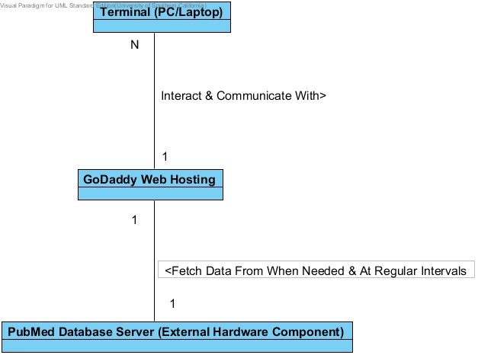
Figure 4: Hardware Component Class Diagram

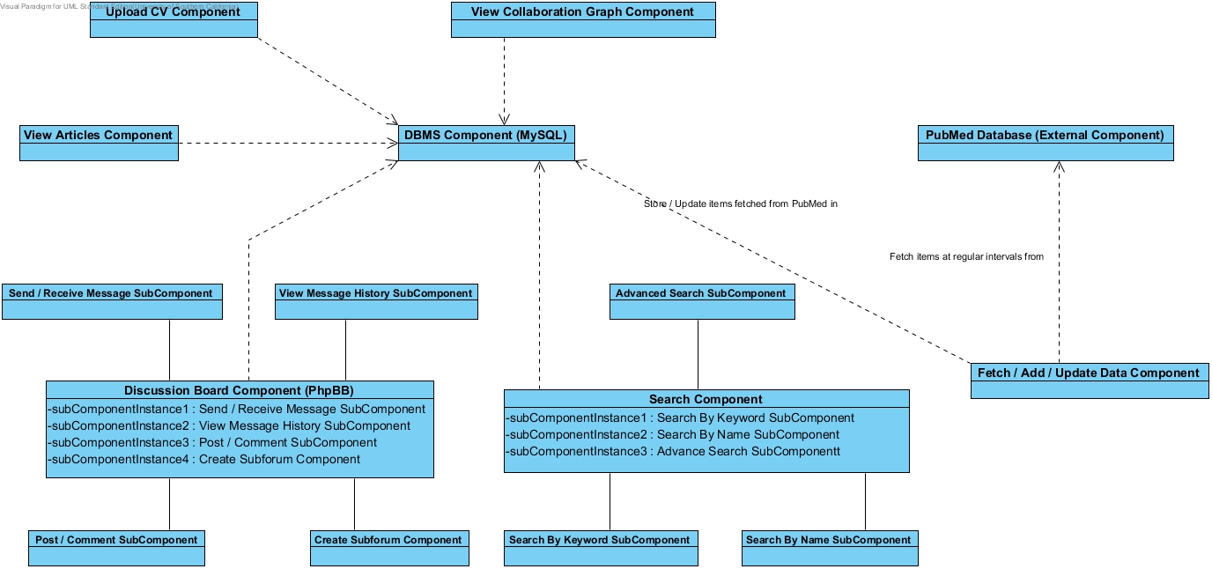
Figure 5: Software Component Class Diagram

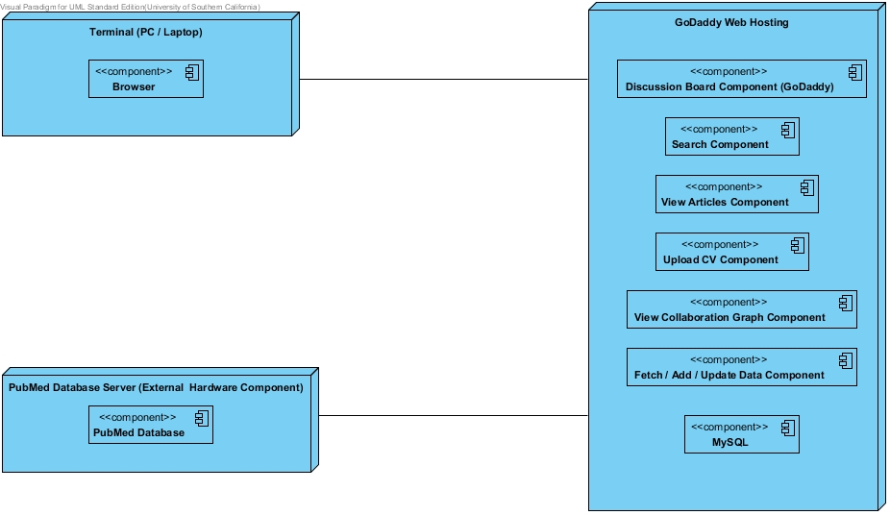
Figure 6: Deployment Diagram

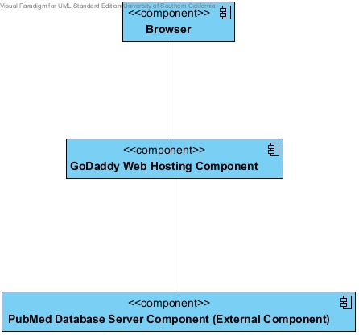
Figure 7: Supporting Software Component Class Diagram

Table 47: Hardware Component Description
Hardware Component | Description
Terminal (PC/Laptop) | Terminals are the PCs and laptops that PTS members use to access GoDaddy by means of requesting web pages via browser.
GoDaddy Web Hosting | GoDaddy is a paid web hosting that includes or stores (in a static way):  - MySQL database  - Web pages & Scripts  - Files (resumes & articles of the PTS members)  In addition, it contain the functionality such as (in a dynamic way):  - Do all the logic processing corresponding to the requests from clients (terminals).  - Fetch and update existing data at regular intervals (once every night at the moment).
Pubmed Database Server (External Component) | Pubmed Database Server is the external component that GoDaddy fetches data from, which here is just used to show the relationship between the components involved in our system.

Table 48: Software Component Description
Software Component | Description
Discussion Board Component (PhpBB) | PhpBB is a paid discussion board COTS that includes the following subcomponents our system needs:  - Create Subforum SubComponent: responsible for creating subforum for members to share information  - Post / Comment SubComponent: responsible for handling members’ post and comment request that facilitate them with communication and interaction.  - Send / Receive Message SubComponent: responsible for processing the functionality of sending and receiving private messages between members.  - View Message History Component: responsible for showing the message history of a member with others.
Search Component | Search Component is the one that handling the search requests from members. There are three kinds of searching subcomponents:  - Search By Keyword SubComponent: responsible for handling keyword-search requests from members. If the items corresponding to the keyword do not exist in the local database, return null.  - Search By Names SubComponent: responsible for handling author-name-search requests from members. If the items corresponding to the name do not exist in the local database, return null.  - Advanced Search SubComponent: responsible for handling advanced-search requests from members. Currently advanced search includes searching members by Country and State. If the items corresponding to the country and state do not exist in the local database, return null.
View Articles Component | View Articles Components simply handles the request to view the list of articles a member has published before in Pubmed.
Upload CV Component | Upload CV Component is responsible for the member to upload their resumes.
View Collaboration Graph Component | View Collaboration Graph Component shows the relationship graph between the member and the others that have been ever collaborated with.
DBMS Component (MySQL) | MySQL is the database (currently we use the free version of it and may transfer into the paid version in the future) that store all the items fetched from Pubmed.
Fetch / Add / Update Data Component | Fetch / Add / Update Data Component is the one that fetches key items from Pubmed at regular intervals and then store them or update the corresponding data in MySQL in the back end. It is the only component in our system that does not directly interact with the users.
Pubmed Database (External Component) | Pubmed Database is the external software component that provides the key items that our system needs.

Table 49: Supporting Software Component Description
Support Software Component | Description
Browser | Browser is the most common component that resides on the terminal that clients use to request web pages from GoDaddy and to interact with it
GoDaddy Web Hosting Component | GoDaddy Web Hosting Component includes MySQL, web pages & scripts and files that are fetched and stored by PTS Application Server Component. In addition, it is where all the logic components reside except for MySQL and Pubmed. All the computation processing is done here.
Pubmed Database Server Component (External Component) | Pubmed Database Server Component is an extern component that provides all the data needed by our system.

Design Classes

Class Diagram
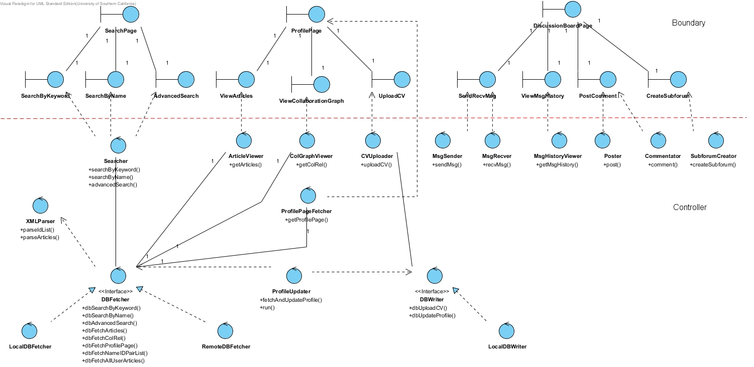
Figure 8: Boundary & Control Class Diagram

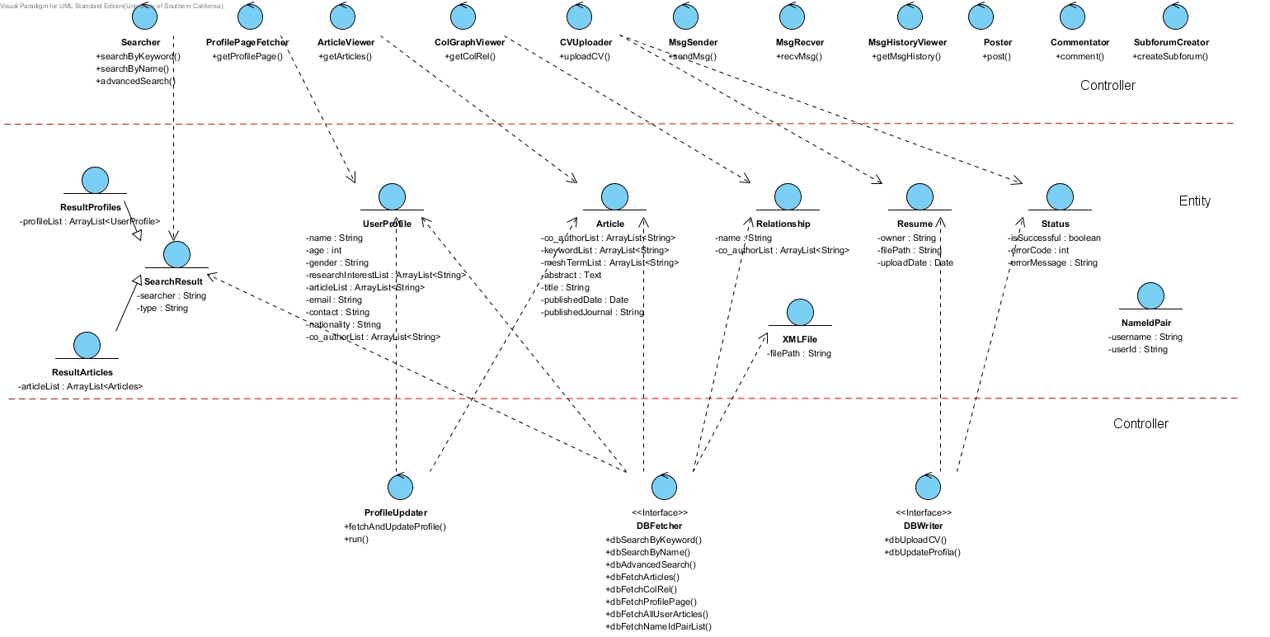
Figure 9: Control & Entity Class Diagram

Table 50: Boundary Class Description
Class | Type | Description
SearchPage | Boundary | Search page containing search by keyword area, search by name area and advanced search area
SearchByKeyword | Boundary | Search by keyword area
SearchByName | Boundary | Search by name area
AdvancedSearch | Boundary | Advanced search area containing country and state dropdown menu selection
ProfilePage | Boundary | User profile page containing all the user information, including view articles area, view collaboration graph area and upload CV area
ViewArticles | Boundary | View article area that the user can view the articles of himself
ViewCollaborationGraph | Boundary | View collaboration area that the user can view the collaboration graph based on the map
UploadCV | Boundary | Upload CV area that allows the user to upload their CV
DiscussionBoardPage | Boundary | Discussion board page containing send/receive message area, view message history area, post/comment area and create subforum area
SendRecvMsg | Boundary | Send/receive message area that allows the user to send/receive message from/to the other PTS members
ViewMsgHistory | Boundary | View message history area containing all the messages the user has ever sent or received
PostComment | Boundary | Post/comment area that allows the user to post or comment on the post
CreateSubforum | Boundary | Create subforum area that allows the user to create a subforum with certain topic

Table 51: Control Class Description
Class | Type | Description
Searcher | Control | The class responsible for searching which contains the following methods:  - SearchByKeyword (userId: String, keyword: String): SearchResult  - SearchByName (userId: String, name: String): SearchResult  - advancedSearch (userId: String, country: String, state: String): SearchResult  Package: pts.ptsrid.component
ArticleViewer | Control | The class responsible for fetching articles which contains the following methods:  - getArticles (userId: String): ArrayList<Article>  Package: pts.ptsrid.component
ColGraphViewer | Control | The class responsible for fetching collaboration relationship which contains the following methods:  - getColRel (userId: String): Relationship  Package: pts.ptsrid.component
CVUploader | Control | The class responsible for uploading CV which contains the following methods:  - uploadCV (userId: String, filePath: String): Status  Package: pts.ptsrid.component
ProfilePageFetcher | Control | The class responsible for fetching user profile which contains the following methods:  - getProfilePage (userId: String): UserProfile  Package: pts.ptsrid.component
MsgSender | Control | The class responsible for sending message which contains the following methods:  - sendMsg ()  Package: pts.ptsrid.component
MsgRecver | Control | The class responsible for receiving message which contains the following methods:  - recvMsg()  Package: pts.ptsrid.component
MsgHistoryViewer | Control | The class responsible for fetching message history which contains the following methods:  - getMsgHistory()  Package: pts.ptsrid.component
Poster | Control | The class responsible for posting which contains the following methods:  - post ()  Package: pts.ptsrid.component
Commentator | Control | The class responsible for commenting on the post which contains the following methods:  - Comment ()  Package: pts.ptsrid.component
SubforumCreator | Control | The class responsible for creating subforum which contains the following methods:  - createSubforum()  Package: pts.ptsrid.component
DBFetcher | Control  Interface | The interface responsible for all the fetching job from database that serves as an auxiliary component to those classes whose task is to read data from database which contains the following methods:  - dbSearchByKeyword (userId: String, keyword: String): SearchResult  - dbSearchByName (userId: String, name: String): SearchResult  - dbAdvancedSearch (userId: String, country: String, state: String): SearchResult  - dbFetchArticles (userId: String, username: String): ArrayList<Article>  - dbFetchColRel (userId: String): Relationship  - dbFetchProfilePage (userId: String): UserProfile  - dbFetchNameIdPairList (): ArrayList<NameIdPair>  - dbFetchAllUserArticles (usernameList: ArrayList<String>): ArrayList<ArrayList<Article>>  Package: pts.ptsrid.db
LocalDBFetcher | Control | The class responsible for fetching data from the local database which should implement the following methods (in terms of other methods that need not be implemented, just remain them empty in the method body):  - dbSearchByKeyword ()  - dbSearchByName ()  - dbAdvancedSearch ()  - dbFetchArticles ()  - dbFetchColRel ()  - dbFetchProfilePage ()  - dbFetchNameIdPairList ()  Package: pts.ptsrid.db.impl
RemoteDBFetcher | Control | The class responsible for fetching data from the remote database (Pubmed) when the local database does not have the data corresponding to the request which should implement the following methods (in terms of other methods that need not be implemented, just remain them empty in the method body):  - dbFetchAllUserArticles()  Package: pts.ptsrid.db.impl
DBWriter | Control  Interface | The interface responsible for all the writing job into database that serves as an auxiliary component to those classes whose task is to write data into database which contains the following methods:  - dbUploadCV (userId: String, filePath: String): Status  - dbUpdateProfile (articles: ArrayList<Article>): Status  Package: pts.ptsrid.db
LocalDBWriter | Control | The class responsible for writing data into the local database which should implement the following methods (in terms of other methods that need not be implemented, just remain them empty in the method body):  - dbUploadCV()  - dbUpdateProfile ()  Package: pts.ptsrid.db.imp
ProfileUpdater | Control | The class responsible for fetching user profiles (including their articles) from the remote server (Pubmed) and update all the existing data in the local database which contains the following methods:  - run (): void  - fetchAndUpdateProfile (): Status  Note that the interval is once every night  Package: pts.ptsrid.component

Table 52: Entity Class Description
Class | Type | Description
SearchResult | Entity | The entity representing the result of search  Package: pts.ptsrid.datamodel
ResultProfiles | Entity | Derived from SearchResult. Return value of the search by name & advanced search  Package: pts.ptsrid.datamodel
ResultArticles | Entity | Derived from SearchResult. Return value of the search by keyword  Package: pts.ptsrid.datamodel
UserProfile | Entity | The entity that contains all the information of the user  Package: pts.ptsrid.datamodel
Article | Entity | The entity representing the article that the user has ever published  Package: pts.ptsrid.datamodel
Relationship | Entity | The entity representing the collaboration relationship between the user and the other members  Package: pts.ptsrid.datamodel
Resume | Entity | The entity representing the CV of the user  Package: pts.ptsrid.datamodel
Status | Entity | The entity representing the status of the post request from the user  Package: pts.ptsrid.datamodel
NameIdPair | Entity | The entity containing the user ID and username  Package: pts.ptsrid.datamodel

Process Realization
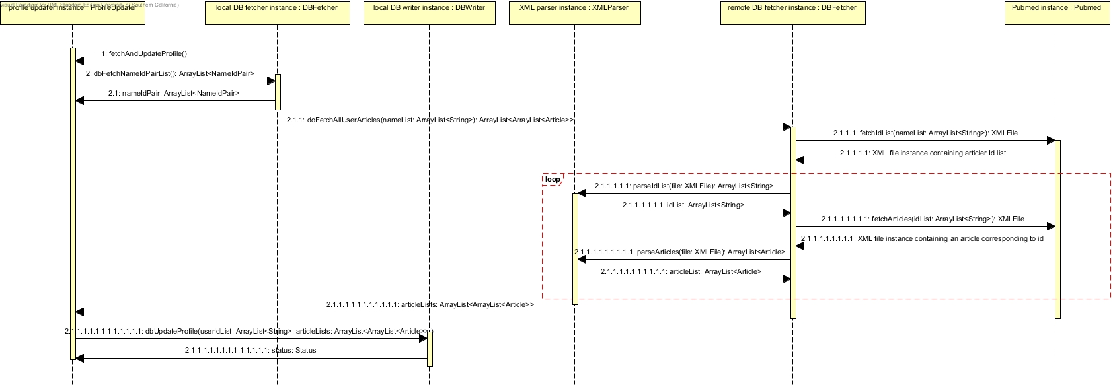 Figure 10: Process Realization Diagram

E-R Diagram (physical level)
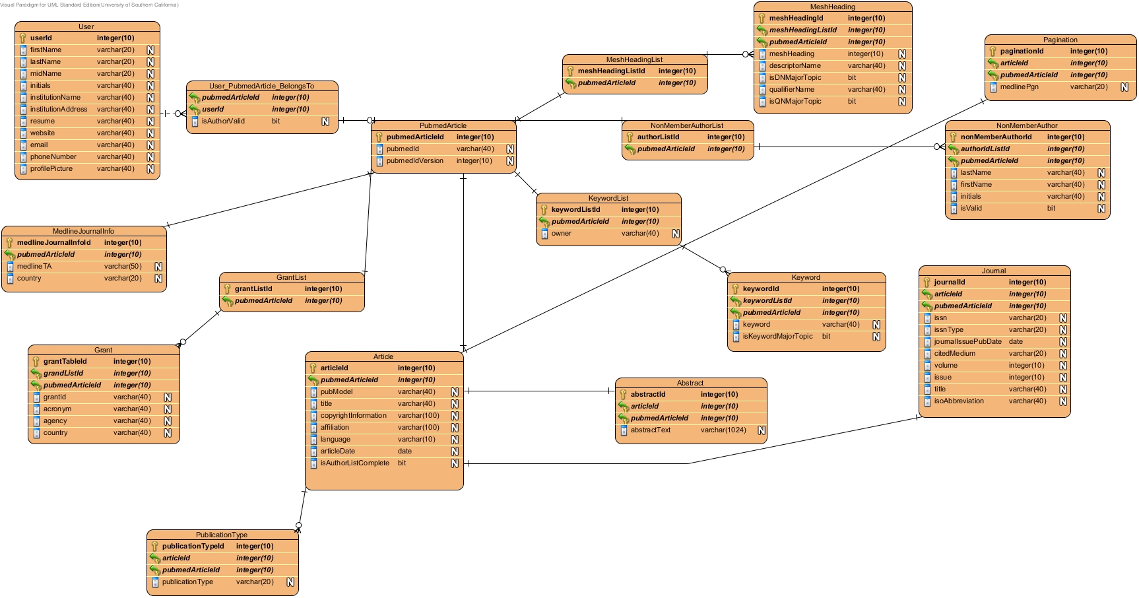

Figure 11: ER Diagram

Design Rationale
Our system PTS-RID is of a typical B/S framework. So we adopt MVC pattern for our project: M corresponds to the Entity Class, V corresponds to the Boundary Class and C corresponds to the Control Class.

In addition to that, regarding the COTS we choose to use, there are two candidates available: myBB and phpBB. Here is the comparison table: (O stands for good, + stands for very good. In addition there is no note here just because of its informality)

Table 33 Comparison table
Criteria | MyBB | phpBB
Documentation | O | +
Modding process | + | O
Additional features | + | O
Security history | O | +
Admin UI simplicity | + | O
Comprehensive settings | O | +
Adding Styles/Themes | + | O

Detailed Comparison:
http://www.forum-software.org/forum-comparator/mybb-vs-phpbb3

According to our client and the table above, finally we determine phpBB as our discussion board COTS. The reason for using it is that our client cares more about the security problem, and we developers tend to choose the one with more detailed user manual for ease of development.

What’s more, the reason to choose GoDaddy as the web hosting is:
- GoDaddy has provided large space for storage of whether the database or the files.
- PTS has deployed there existing system on GoDaddy for a long time without any problem, so the stability and the reliability could be guaranteed.
- Some features like login and logout have been already scratched by PTS. Therefore staying on the same server with PTS existing system facilitates integration.

Architectural Styles, Patterns and Frameworks
Table 54: Architectural Styles, Patterns, and Frameworks
Name | Description | Benefits, Costs, and Limitations
B/S | Brower/server architecture pattern | Benefit: client side (browser) do not need to do much  Costs: not much  Limitations: Server may undertake too much workload

